ORIENTATION 2022
RED CAP APPLICATION PACKET

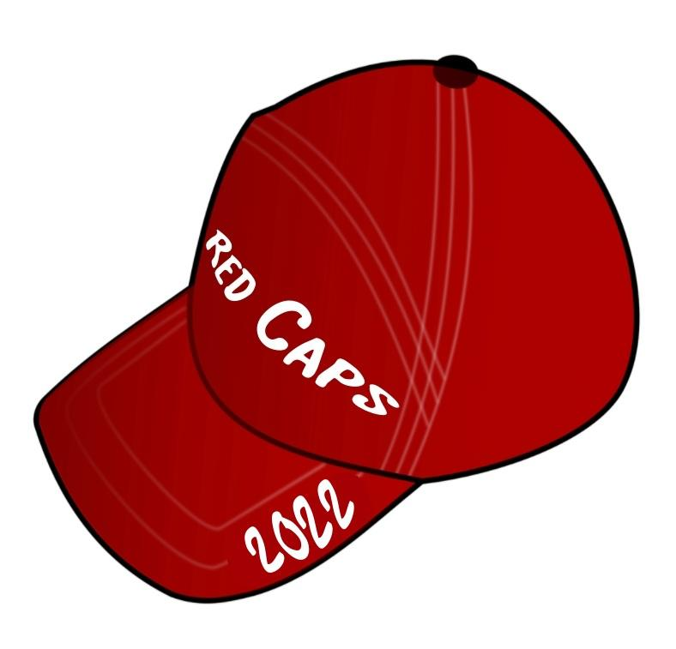

APPLICATIONS DUE BY February 18th, 2022
E-MAILED TO: redcap@hartford.edu
BY: 2:00 PM

What is a Red Cap?:

Red Caps are orientation student leaders who are eager to help new students and their parents learn about life at the University of Hartford. A Red Cap is friendly, helpful, outgoing, enthusiastic, and wants to promote the University and the opportunities it has to offer.
Red Caps work during the early and late summer to welcome students and parents to the University of Hartford, engage them in conversation and activities, and connect them to peers and University resources. Through individual conversations, group activities, academic advising, and various programs, Red Caps help the incoming students and their parents become familiar and comfortable with the University. As a Red Cap, you will have the opportunity to work closely with the University's faculty and staff in an informal setting.
Red Caps will not only become part of the orientation program, but they also become a member of a very special family. Through training sessions and fun activities, Red Caps form lasting friendships and memories that will stay with them for the rest of their lives.

Red Cap Application Information & Timeline:

Important Information-please read the following carefully

- Red Caps must have a cumulative GPA of 2.5 by the end of the Fall 2022 semester. Red Caps who drop below the grade requirement after being hired for the position may be terminated from their position.

- Red Caps should not have any current or previous student conduct charges or sanctions. If you have questions about your particular situation, contact Christine Riley at riley@hartford.edu

- Applications must be submitted via e-mail to redcap@hartford.edu no later than Friday February 18th 2022 by 2:00 PM.

- Applicants must be available to attend all selection activities. See "Orientation Timeline" below for specific dates. Any questions or concerns, please contact Nathan Murphy at namurphy@hartford.edu.

- Applicants who are selected to be a part of the 2022 Red Cap team must be available for all Training & Orientation dates beginning June 2022 and ending late August 2022. See "Orientation Timeline" below for specific dates.

- Red Caps are paid a total of $650.00 split into two pays ($475.00 after sessions 1 through 3, and $175.00 after Start-Strong).

If you have questions or concerns about becoming a Red Cap, or this application, please do not hesitate to contact either:

Nathan Murphy Christine Riley
Graduate Assistant of Orientation OR Director of Orientation
namurphy@hartford.edu riley@hartford.edu
(413)544-1345 (860)768-5754

2022 Red Cap Orientation Timeline

Below is a timeline of all dates and activities of the entire Red Cap/Orientation Process:

February ‘22
Feb 18 | Application Due by 2:00 PM | E-mailed to: redcap@hartford.edu
Feb 18 | Selection Process Day 1 (5:00- 7:00 PM)
Feb 19 | Selection Process Day 2 (9:00AM- 1:00 PM)
Feb 20 | Selection Process Day 3 (9:00AM- 1:00 PM)

Note: Selection Process days include activities and games so that we can get to know who you are and how you interact with the other candidates. Candidates must be available to participate in all three days of the selection process. Eliminations may be made after each day and those candidates who are not eliminated after day three may be invited to participate in an interview with the Orientation Committee.

Feb - March ‘22
Feb 25 – Mar 18 | Individual Candidate Interviews

May - June ‘22
May 28 | Red Cap Move-in
May 28- Jun 2 | Red Cap Training
Jun 3 | Orientation Session I
Jun 4 | Orientation Session II
Jun 5 | Orientation Session III
Jun 6 & 7 | Red Cap Wrap-Up

August ‘22
Aug 14 | Red Cap Move-in
Aug 15 – Aug 18 | Red Cap Training
Aug 19 | Orientation Session IV
Aug. 19/20 | First-Year Move-in
Aug 20 - 21 | Start-Strong
Aug 22 | Fall Classes Begin
2022 RED CAP APPLICATION

(Please fill out the information, and answer each of the questions below.)

Full Name: | ID #:
Hartford E-Mail: | Cell Phone #:
School/ College: | Major:
Cumulative GPA: | Expected Date of Graduation:
Pronouns:

QUESTIONS

- Why do you believe it is important for students to become connected to the University and each other?

2. What does it mean to be a great Red Cap? What personal qualities do you have to offer the 2021 Orientation Program?

3. Please list any organizations, activities, and work experience you have been a part of that would contribute to your experience as a Red Cap. How have these experiences prepared you for becoming a Red Cap?

4. What are your strengths and weaknesses? How do you believe each of these impacts your leadership ability?

5. Based on your experience as a student who went through Orientation, would there be anything that you would add or remove from the program? Is there anything you would like to see done differently? Please explain.

6. How did you hear about Red Caps? Highlight all that apply:
- Info Session
- Instagram Takeover
- A previous Red Cap(s) 🡪 ________________________
- Other:

Please E-Mail Applications to: redcap@hartford.edu | Due date: February 18th, 2022 by 2:00 PM

